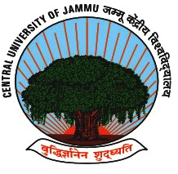

जम्मू केंद्रीय विश्‍वविद्यालय
Central University of Jammu
राया-सूचानी (बागला), जिला सांबा -181143, जम्मू (जम्मू एवं कश्‍मीर)
Rahya-Suchani (Bagla), District Samba – 181143, Jammu (J&K)

UNDERTAKING
(For issuance of university domain email ID)

We, the undersigned through this undertaking confirm and undertake that the issuance of the university domain email ID doesn’t imply any current or future employment by the university.

We shall responsibly access the email ID only for research related purpose and shall intimate the Digital Cell on completion of the project/research for deactivation of the email.

List of the Students

S. No. | Name | Registration No. | Contact No. | Email address | Signature
1
2
3
4
5
6
7
8
9
10
11
12

__________________________________________________________________________________
To be forwarded by the Head of the Department
I authorize the above students/research scholars to use the university domain email ID in official capacity only. The department will intimate Digital cell, on completion of the project/research for deactivation of the email.

Head of the Department

